
WWII Veteran Ivan Cregger
Is Turning 100 Years Young On Nov 14th

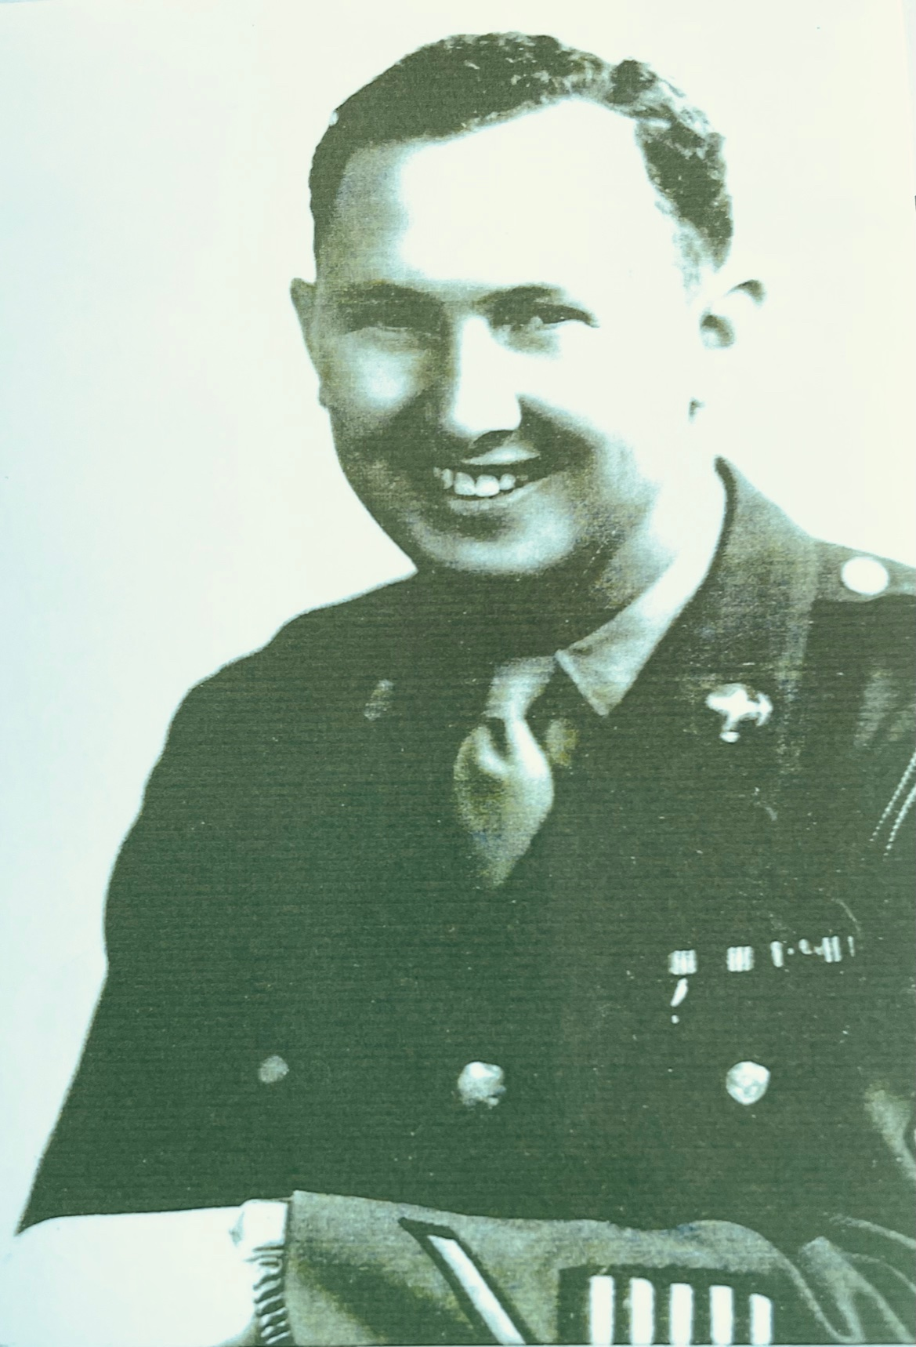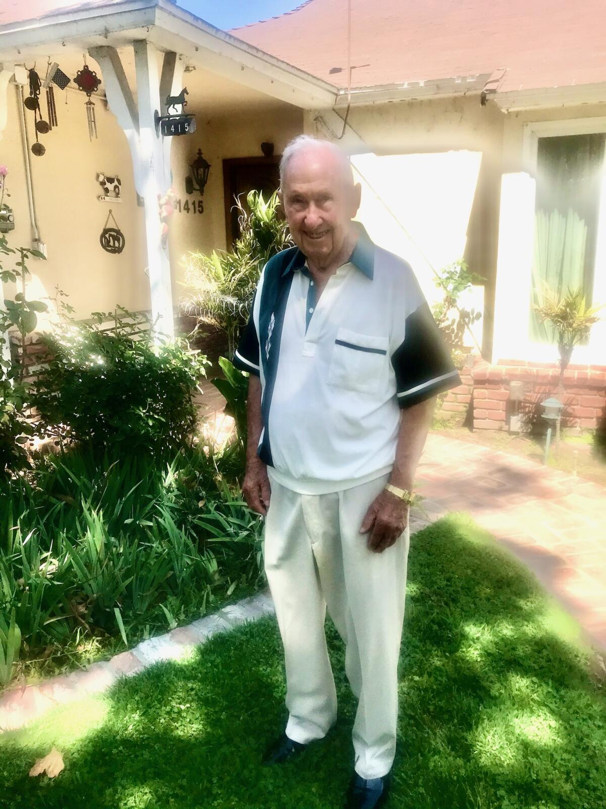

Staff Sergent Ivan Cregger served in the U.S. Army Air Corp. He enlisted in January 1942 and served until September 1945.

Ivan served in the 9th, 12th, and 15th Air Forces as an instrument technician and as a B-24 Liberator crew chief. Ivan served in the Mediterranean Theater of War, including the Middle East (Egypt), North Africa (Libya), and Italy (Naples, Rome, and Foggia).

Let’s make Ivan’s birthday extra special by sending
him lots of birthday cards:
1415 West Morningside Drive, Burbank CA 91506

Contact: Donna Hester – donna@thehesters.com

