How to Sew Prefold Cloth Diapers

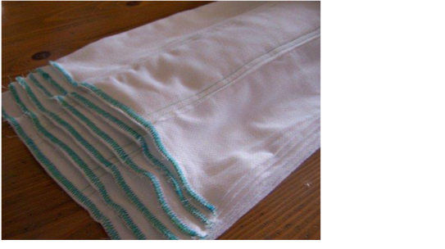

*birdseye diapers*

Cloth diapers can be made from a wide range of materials: twill, jersey, birdseye, flannel, and terry cloth. Cotton and hemp are the most commonly used fibers, though traditionally linen was also used (probably due to availability).

When choosing fabric for your diapers look for something that is soft an absorbent, and will stand up to many washings. There is nothing worse than having the cute diapers you made wear out long before your child has outgrown them.

To make quality diapers, new fabric is **not** a requirement! There are many source of recyclable fabric that you may want to consider. Flannel top sheets and receiving blankets are two of my favorite sources, as they have already been washed numerous times, but are rarely worn out.

Receiving blankets can be picked up inexpensively at yard sales and second hand stores. Better yet, ask a friend or two who is done having children for their leftovers. These may be stained but after a trip through your washing machine, they are ready to use. Two newborn or infant sized diapers can be made from each receiving blanket.

Some recommend t-shirts as a source of fabric. I have used them before and they wear well, but are not overly absorbent. Also, they can be difficult to pin.

**Basic Construction**

Traditionally, prefold diapers are made of two pieces of cloth cut to the length of the diaper. This piece of cloth is folded to the desired size and sewn.

Prefolds can also be made of a single layer of cloth with an absorbent core. Extra diaper fabric, terry cloth and cotton batting all work well to make the core.

The width of the fabric you are using and the size of the diapers you are making will help determine which method you use.

* Fabric used for making diapers comes in widths ranging between 27" and 60", 27"-36" being most common.
* When using fabric wider than 36", consider using a piece of polyester batting or polar fleece to help it dry quicker.

**Size Chart**

Newborn: 10" x 13" Infant: 11" x 15" Standard: 13" x 17"

**Supplies List**

* 1/2 - 2/3 yard cloth per diaper, depending on size.
* Fabric or batting for liner (optional if using 45" wide fabric)
* Thread
* Straight pins
* Scissors
* Pencil or chalk
* 24" Quilting Ruler **or** Yardstick
* Sewing Machine

**Prepare Your Fabric**

• Diapers you buy are made with fabric that has not been washed, and will often shrink 25% or more over time. Some companies make their diapers large to accommodate this.

Before cutting your fabric, wash it fabric *at least three times* in hot soapy water and tumble dry. This is needed to preshrink the fabric.

Follow the package directions for preshrinking batting. Iron as needed before cutting.

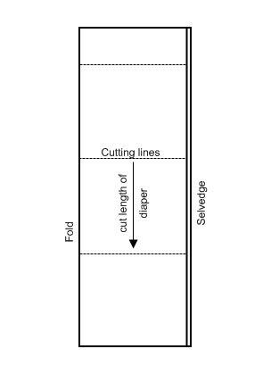

**Cutting Instructions**

Fold fabric right sides together lengthwise along grain line, matching the selvedge edges.

Square off one end, using a quilting ruler or square piece of paper and yard stick. This is the end you will measure from, to mark off the diapers.

Measuring lengthwise, mark the desired length of the diaper plus one inch.

* Newborn: 14"
* Infant: 16"
* Standard: 18"

Draw lines across fabric, ensuring squareness, and cut.

**Cotton Liner:**

* Newborn: 7 3/4" x 14", use folded in half lengthwise.
* Infant: 7 3/4" x 16", use folded in half lengthwise.
* Standard: 8" x 18", use folded in half lengthwise.

**Polyester liner** (optional, use only when cotton liner is not wanted)**:**

* Newborn: 3 3/4" x 14"
* Infant: 3 3/4" x 16"
* Standard: 4" x 18"

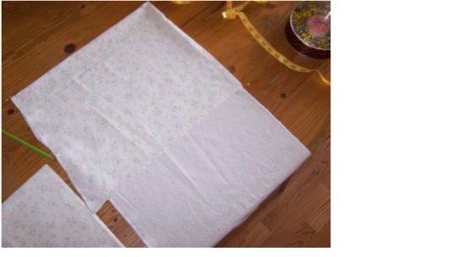

*Mark center of outside section of diaper, using straight pins.*

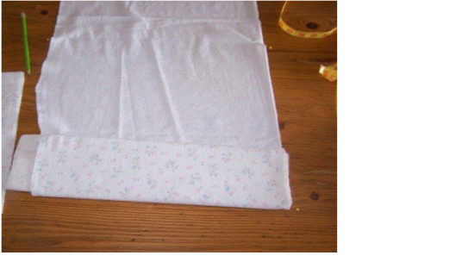

*Roll extra fabric around liner to form an absorbent core.*

**Basic Folding Instructions**

**1.** Measuring from one selvedge measuring, mark off the out side of the diaper (finished size x 2 + 2"):

* Newborn: 22"
* Infant: 24"
* Standard: 28"

The rest of the fabric will become part of the absorbent core.  
**2.** Fold from the selvedge to the pins to mark the center of the out side section. **3.** Place liner on opposite selvedge and carefully roll towards the pins.

• You may want to measure out from the pins to know where to begin rolling. i.e. there is not aways enough fabric to make an even number of folds.

**4.** When you reach the pins, fold the diaper so that the liner is centered over the pins that mark the center of the diaper.

**5.** Fold the free selvedge to meet the pins marking the outside of the diaper. Pin to secure before sewing. **Folding an Infant sized Diaper out of a Recieving Blanket**

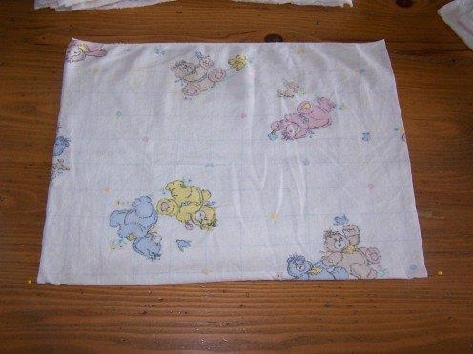

*Mark the middle of the long edge with a pin on each side.*

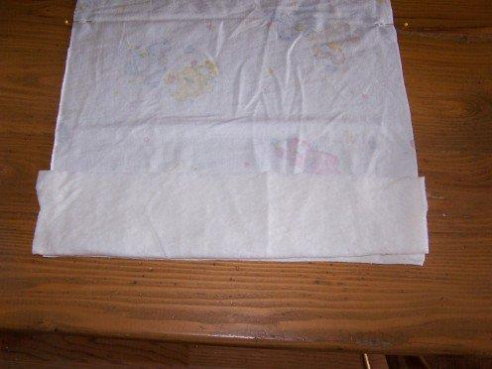

*Open fabric and place liner along opposite selvedge.*

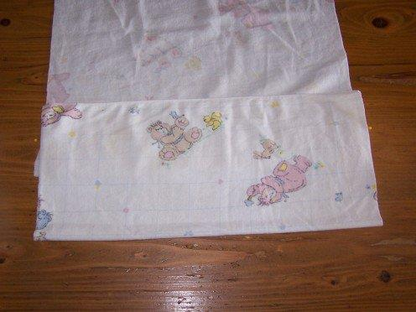

*Fold fabric over liner centering over pins.*

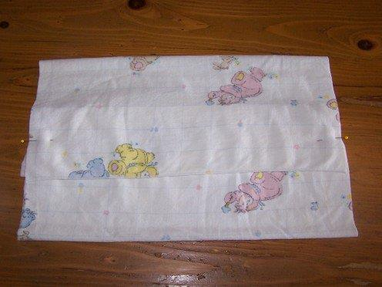

*Fold free selvedge over liner. Pin to secure.*

**Finished Diaper Sewing Guide**

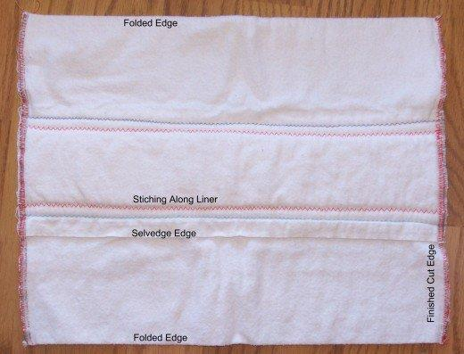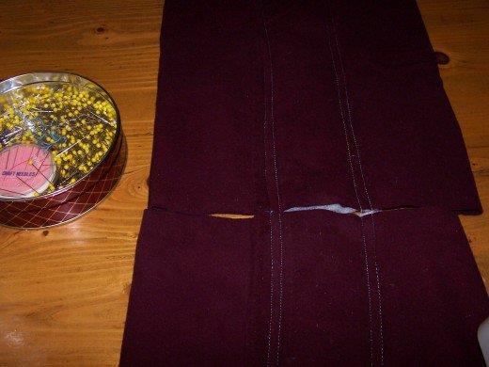

*Assembly line type construction speeds up the sewing process.*

**Sewing Instructions**

**1.** Beginning with the open selvedge edge, stitch through all layers using either a zig-zag or straight stitch on a long setting, such as 8 stitches per inch or #3.

• If your machine is having difficulty sewing through all layers, use a walking foot or help feed the fabric through by keeping a firm grip on the diaper as it comes out the back of the machine.

**2.** Turn diaper and stitch through the other edge of the liner.

**3.** Now stitch again through the all layers 3/8" from the first set of stitching lines. This will make a sturdy diaper that quickly wicks the moister away.

• Using assembly line type construction will save time and thread, as it is unnecessary to cut the thread between diapers. Simply start a new one when the first one has cleared the feed.

**4.** When the liner has been secured, zig-zag the cut edges with a wide close stitch or secure with a surger. I zig- zagged mine from both sides to make sure I had caught all layers of fabric and to ensure they would not unravel.

**Thrifty and Time-Saving Tips**

* Diapers don't have to be white!
* Flannel top sheets, new flannel shirts and receiving blankets are a quick easy source of fabric that you may

already have.

* Do not use worn out shirts or bottom sheets. They will not last long enough to make it worth while. The same goes for cheap flannel, such as found at Wal-Mart. I have had brand new fabric wear out in three months.
* Making diapers is a great way to use up all those little spools of thread that are cluttering up your sewing supplies. When making my son diapers this last time, I emptied more than 30 partial spools of thread.
* Wind several bobbins before you begin sewing. I used one full bobbin for every 4 diapers I made.
* When buying fabric, consider hemp. It is soft yet durable, more absorbent than cotton and grown pesticide free.